April 20th – April 24th  8th Grade Social Studies

**Directions:** Read the following sections and answer the questions in the spaces provided. Use the R.A.C.E. (Restate, Answer, Cite, and Explain) strategy to create answers in complete sentences.

**Dust Bowl**

**What was the Dust Bowl?**  
  
The Dust Bowl was an area in the Midwest that suffered from drought during the 1930s and the Great Depression. The soil became so dry that it turned to dust. Farmers could no longer grow crops as the land turned into a desert. Areas of Kansas, Colorado, Oklahoma, Texas, and New Mexico were all part of the Dust Bowl.  
  
**How did it get so dusty?**  
  
A number of factors contributed to the Dust Bowl. The first was a terrible drought (lack of rain) that lasted for many years. With so little rain the soil dried out. Also, much of the region had been plowed up by farmers to grow wheat or to graze cattle. The wheat did not anchor the soil or help hold moisture. After years of abuse, the topsoil was destroyed and turned into dust.

1. What helped contribute to the dust bowl?

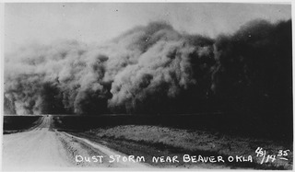  
*Dust Storm in Oklahoma*  
Source: National Archives

**Dust Storms**  
  
With so much of the soil turned into dust, there were huge dust storms in the Midwest. The dust made it hard for people to breathe and piled up to the point where houses were buried. Some dust storms were so big that they carried dust all the way to the East Coast of the United States.

1. What kind of issues did the dust storms create? Please explain.

**Black Sunday**  
  
Giant dust storms were called "black blizzards." One of the worst dust storms occurred on Sunday April 14, 1935. High speed winds caused great walls of dust to engulf entire cities and regions. This dust storm was called "Black Sunday." It was said that the dust was so thick that people couldn't see their own hand in front of their face.

**What did the farmers do?**  
  
Living in the Dust Bowl became nearly impossible. Dust got everywhere. The people spent much of their time trying to clean up the dust and keep it out of their houses. Many of the farmers had to move as they could not survive. Crops would not grow and livestock were often choked to death by the dust.

1. What did Farmers have to do as a result of the dust bowl?

**Okies**  
Many of the farmers and their families migrated to California where they had heard there were jobs. Jobs were hard to come by during the Great Depression. They were desperate for any work, even if they had to work long days just for enough food to survive. Poor farmers who moved from the Dust Bowl to California were called "Okies." The name was short for people from Oklahoma, but was used to refer to any poor person from the Dust Bowl looking for work.

1. What was an Okie? Why were they called Okies?

**Government Aid Programs**  
The federal government implemented programs to help the farmers that stayed in the Dust Bowl. They taught farmers proper farming practices to help preserve the soil. They also purchased some land to let it regenerate in order to prevent future dust storms. It took some time, but much of the land had recovered by the early 1940s.

1. What did the government do to help the farmers?

**GO TO NEXT PAGE**

**Images of the Great Depression**

Directions: In this section you will be shown several image from the Great Depression. The images are of real people and situations. Look closely and answer the questions in complete sentences.

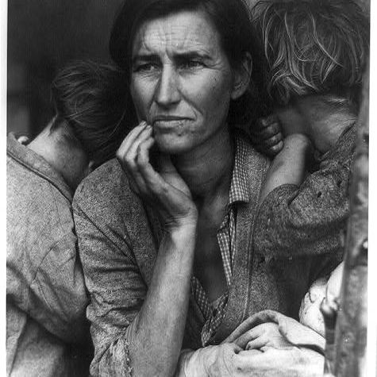

1. Give three words you would use to describe this woman?
2. Why do you think she looks like this?

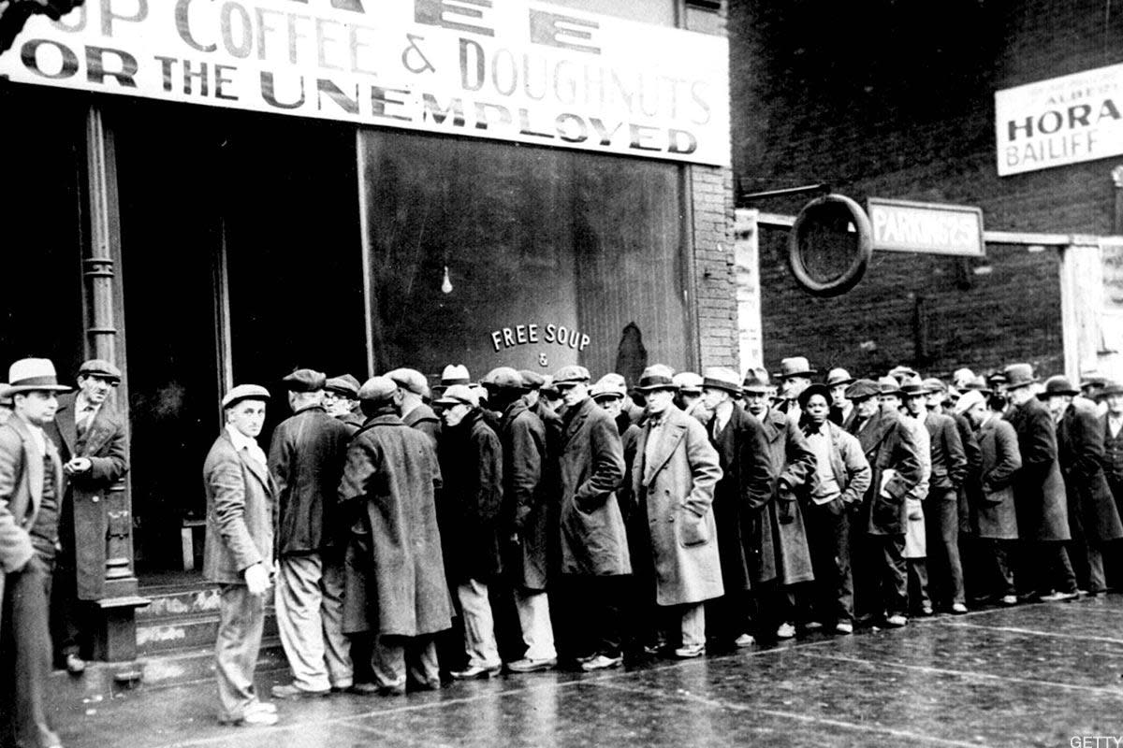

1. What do you think these people are waiting in line for?
2. What type of people do think stood in these types of lines?

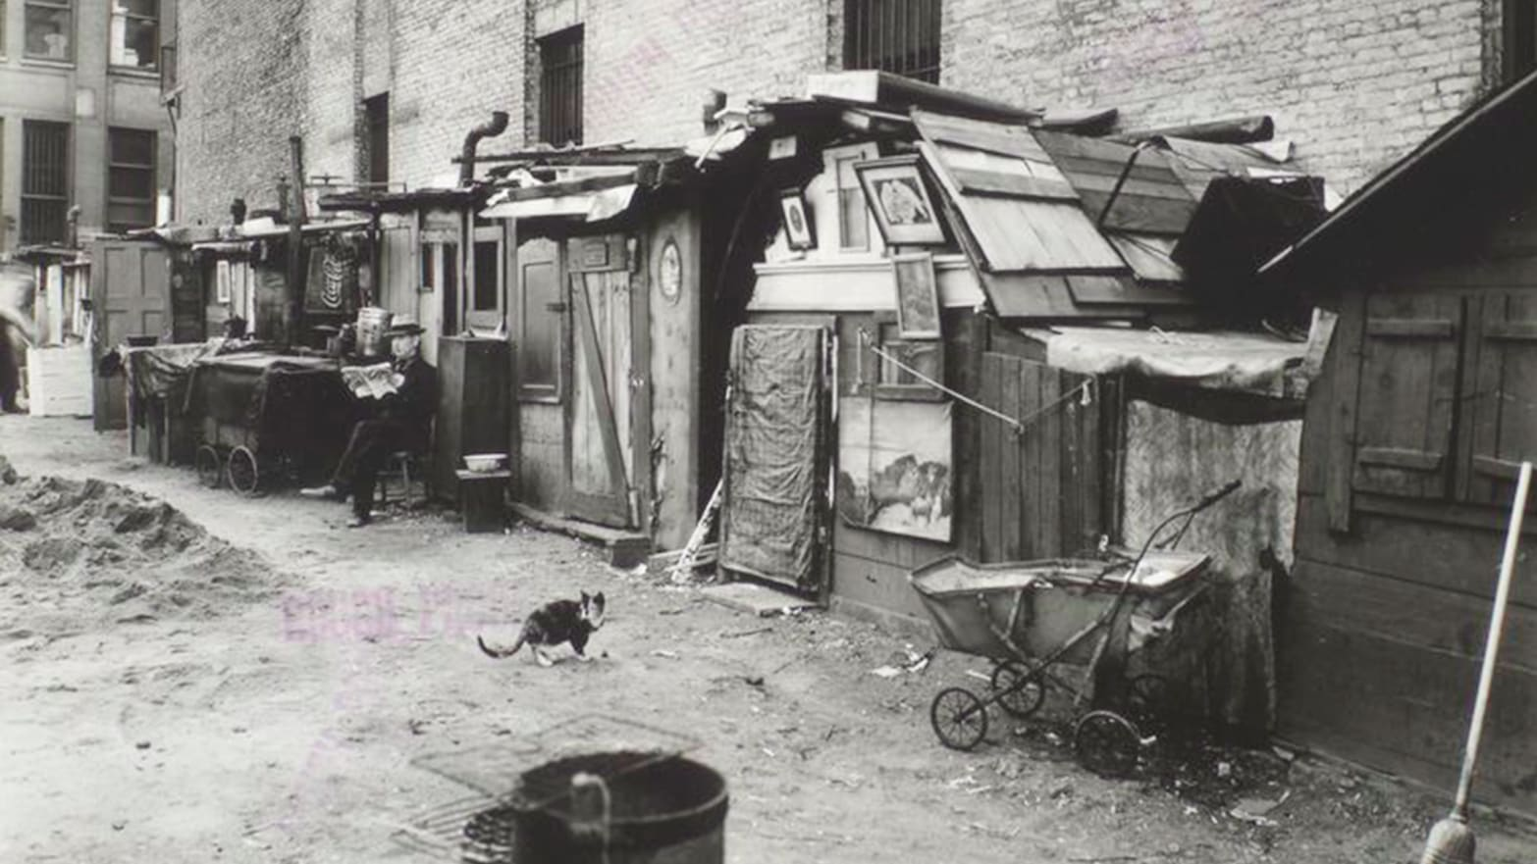

1. How would you describe these buildings?
2. Why might people live in these kinds of buildings?

**FDR's Alphabet Soup**

The New Deal was clearly the most ambitious legislative program ever attempted by Congress and an American President.

Progressive politicians saw their wildest dreams come alive. The Great Depression created an environment where the federal government accepted responsibility for curing a wide array of society's ills previously left to individuals, states, and local governments. This amount of regulation and involvement requires a vast upgrading of the government bureaucracy. An armada of government bureaus and regulatory agencies was erected to service the programs of the New Deal. Collectively, observers called them the "**ALPHABET AGENCIES**."

While the CCC, CWA, and WPA were established to provide relief for the unemployed, the New Deal also provided a program intended to boost both industries and working Americans. The National Industrial Recovery Act contained legislation designed to spark business growth and to improve labor conditions. The National Recovery Administration attempted to create a managed economy by relieving businesses of antitrust laws to eliminate "wasteful competition." The NRA, like the AAA for farmers, attempted to create artificial scarcity with commodities. The hope was that higher prices would yield higher profits and higher wages leading to an economic recovery.

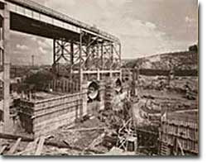  
In 1933, Roosevelt asked Congress to create "a corporation clothed with the power of government but possessed of the flexibility and initiative of a private enterprise." The Tennessee Valley Authority was born, and economic recovery came to eastern Tennessee.

To avoid charges of **SOCIALISM**, the NRA allowed each industry to draw up a code setting production quotas, limiting hours of operation, or restricting construction of new factories. Once the President approved each code, pressure was put on each business to comply. A **PROPAGANDA** campaign reminiscent of World War I ensued. Firms that participated in the NRA displayed blue eagles reminding consumers of a company's apparent patriotism.

To enlist the support of **LABOR UNIONS**, the NRA outlawed child labor, set maximum hours, and required a **MINIMUM WAGE**. The greatest victory for labor unions was the guarantee of the right to collective bargaining, which led to a dramatic upsurge in union membership. Unfortunately, the NRA did little to improve the economy. The increase in prices actually caused a slight slowdown in the recovery. Workers complained that participating industries found loopholes to violate minimum wage and child labor obligations. When the Supreme Court finally declared the NRA unconstitutional in 1936, many had taken to calling it the "National Run Around."  
By displaying the Blue Eagle, businesses indicated that they had joined the National Recovery Administration. By 1933, over 2 million participants in the NRA were hanging Blue Eagle window signs, posters and flags.

The government blazed other new trails by creating the **TENNESSEE VALLEY AUTHORITY** in May 1933. The geography of the Tennessee River Valley had long been a problem for its residents. Centuries of resource exploitation contributed to soil erosion and massive, unpredictable floods that left parts of seven states impoverished and underutilized.

Funds were authorized to construct 20 new dams and to teach residents better soil management. The hydroelectric power generated by the TVA was sold to the public at low prices, prompting complaints from private power companies that the government was presenting unfair competition. Soon **FLOOD CONTROL** ceased to be a problem and FDR considered other regional projects.

There seemed to be no end to the alphabet soup. The **SECURITIES AND EXCHANGE COMMISSION** (SEC) was created to serve as a watchdog on the stock market. The **FEDERAL HOUSING AUTHORITY** (FHA) provided low interest loans for new home construction. The **HOME OWNERS LOAN CORPORATION** (HOLC) allowed homeowners to refinance mortgages to prevent foreclosure or to make home improvements. The **UNITED STATES HOUSING AUTHORITY** (USHA) initiated the idea of government-owned low-income housing projects. The **PUBLIC WORKS ADMINISTRATION** (PWA) created thousands of jobs by authorizing the building of roads, bridges, and dams. The **NATIONAL YOUTH ADMINISTRATION** (NYA) provided college students with work-study jobs. The **NATIONAL LABOR RELATIONS BOARD** (NLRB) was designed to protect the right of collective bargaining and to serve as a liaison between deadlock industrial and labor organizations.

Critics bemoaned the huge costs and rising national debt and spoon-feeding Americans. Regardless, many of the programs found in FDR's "alphabet soup" exist to this day.

1. Pick 3 new government agencies from the text created during the Great Depression by President Roosevelt and explain what they did. Use complete sentences.

**STOP! Submit this by 5:00 pm on April 24th.**